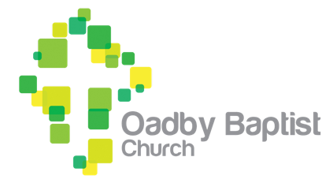
Oadby Baptist Church Complaints Form

Your details
Name
Address

Email address
Phone number

Your complaint
Date
Group (where applicable)
Persons (where applicable)
Complaint about: Briefly describe the nature of your complaint

Supporting information:
State the matter or name of the person who is the subject of the complaint, what happened, when and where.
Provide the contact details or statements of any witnesses. Include any additional information that you think
would be helpful.
If complaining about a decision, explain what the decision was about, when it was taken, and who made it.
Explain what impact this decision has had, or you may fear will have, and upon whom.
Provide any additional information that you believe would be helpful.

Have you tried to resolve this matter informally? |  | Yes
 |  | No
If you tried to resolve this matter informally, what happened?
State who you dealt with, when and where, what information you provided to them, and what you felt was
unsatisfactory about the outcome.

If you decided not to resolve this matter informally, please explain why here:

.

Action sought:
Describe what actions you want the church to take. While the charity trustees cannot promise to do what you ask, it would be helpful to understand what you are seeking.

.
The church will treat your data carefully and in accordance with the church’s Data Protection Policy. The church cannot guarantee to keep the fact and details of your complaint confidential if it is necessary and proportionate to share your data in order to review and resolve your complaint.

Please return this form to the Church Secretary, Chris Swan on:
chris.swan@oadbybaptist.church
or in writing via the church office:
Mrs Chris Swan, Oadby Baptist Church, Leicester Rd, Oadby, Leicester, LE2 5BD.

